|  |  |  |  |
| --- | --- | --- | --- |
| 1 | | 90,000 | |
| **NUMERO DE FRONTERAS** | | **ENERGIA AGREGADA** | |
|  | | | |
| 232,753,461 | 107 | | 9,923,020 |
| INGRESO 2019 | DÍAS CERTIFICADOS 2019 | | ENERGIA RESPALDADA 2019 |
|  | | | |
| 383,017,777 | 162 | | 14,345,178 |
| INGRESO 2020 | DÍAS CERTIFICADOS 2020 | | ENERGIA RESPALDADA 2020 |
|  | | | |
| 357,962,154 | 174 | | 15,656,056 |
| INGRESO 2021 | DÍAS CERTIFICADOS 2021 | | ENERGIA RESPALDADA 2021 |

**HISTORICO REINTEGRO DDV**

|  |  |  |  |
| --- | --- | --- | --- |
|  | **2019** | **2020** | **2021** |
| **ENE** | - | 61.07 | 48.22 |
| **FEB** | 22.42 | 83.59 | 54.94 |
| **MAR** | 1.49 | 99.8 | 31.9 |
| **ABR** | - | 2.15 | 2.22 |
| **MAY** | - | 17.7 | 47.34 |
| **JUN** | 22.86 | 8.47 | - |
| **JUL** | 52.42 | 52.11 | 51.02 |
| **AGO** | 35.57 | 58.13 | 54.04 |
| **SEP** | 61.6 | - | 35.42 |
| **OCT** | 36.39 | - | 32.85 |
| **NOV** | - | - | - |
| **DIC** | - | - | - |

**Los valores de la tabla están en millones de COP**

**REINTEGRO MECANISMO DDV OCTUBRE 2021**

|  |  |  |  |  |  |
| --- | --- | --- | --- | --- | --- |
| FECHA | TIPO DIA | CANTIDADES RESPALDO | PRECIO PONDERADO USD | TRM | PNETO |
| 2021-10-06 | Miércoles | 89,997 | 5.98 | 3,784.44 | 1,824,899 |
| 2021-10-07 | Jueves | 89,994 | 5.98 | 3,784.44 | 1,824,838 |
| 2021-10-08 | Viernes | 89,991 | 5.98 | 3,784.44 | 1,824,777 |
| 2021-10-09 | Sábado | 89,997 | 5.98 | 3,784.44 | 1,824,899 |
| 2021-10-10 | Domingo - Festivo | 89,994 | 5.98 | 3,784.44 | 1,824,838 |
| 2021-10-11 | Lunes | 89,997 | 5.98 | 3,784.44 | 1,824,899 |
| 2021-10-12 | Martes | 89,994 | 5.98 | 3,784.44 | 1,824,838 |
| 2021-10-13 | Miércoles | 89,997 | 5.98 | 3,784.44 | 1,824,899 |
| 2021-10-14 | Jueves | 89,994 | 5.98 | 3,784.44 | 1,824,838 |
| 2021-10-15 | Viernes | 89,997 | 5.98 | 3,784.44 | 1,824,899 |
| 2021-10-16 | Sábado | 89,994 | 5.98 | 3,784.44 | 1,824,838 |
| 2021-10-17 | Domingo - Festivo | 89,994 | 5.98 | 3,784.44 | 1,824,838 |
| 2021-10-18 | Domingo - Festivo | 89,994 | 5.98 | 3,784.44 | 1,824,838 |
| 2021-10-19 | Martes | 89,997 | 5.98 | 3,784.44 | 1,824,899 |
| 2021-10-20 | Miércoles | 89,997 | 5.98 | 3,784.44 | 1,824,899 |
| 2021-10-21 | Jueves | 89,994 | 5.98 | 3,784.44 | 1,824,838 |
| 2021-10-22 | Viernes | 89,994 | 5.98 | 3,784.44 | 1,824,838 |
| 2021-10-23 | Sábado | 89,994 | 5.98 | 3,784.44 | 1,824,838 |

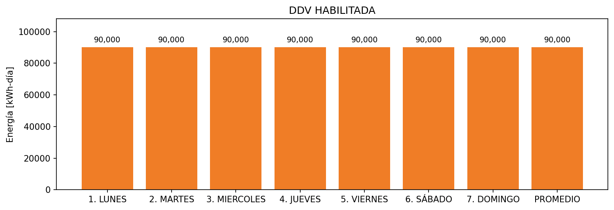

|  |  |  |  |  |  |  |  |  |  |
| --- | --- | --- | --- | --- | --- | --- | --- | --- | --- |
| **FRONTERA** | **COD SIC** | **FRT DDV** | **TIPO DDV** | **PROMEDIO** | **PRÓXIMA ACTUALIZACIÓN** | **MARGEN DE ERROR** | **ÚLTIMA PRUEBA DDV** | **DÍAS PARTICIPACIÓN** | **FECHA REFERENCIA PRÓXIMA PRUEBA DDV** |
| CERAMICA SAN LORENZO INDUSTRIAL DE COLOMBIA S.A. | Frt22236 | Frt36275 | GPE | 90,000 | 2023-04-15 | NO APLICA | 2021-11-25 | 0.0 | 2022-03-17 |